Lab Assignment #2
Insertion Sort

Full Name: Shreyas Srinivasa
BlazerId: SSRINIVA

CS 303 Algorithms and Data Structures
Spring 2023

Problem Specification
The purpose of this project was to implement an algorithm for insertion sort and measure its execution time with a number of datasets of progressively increasing size. This execution time was further used to study the connection between real time performance and theoretical complexity analyses.

Program Design
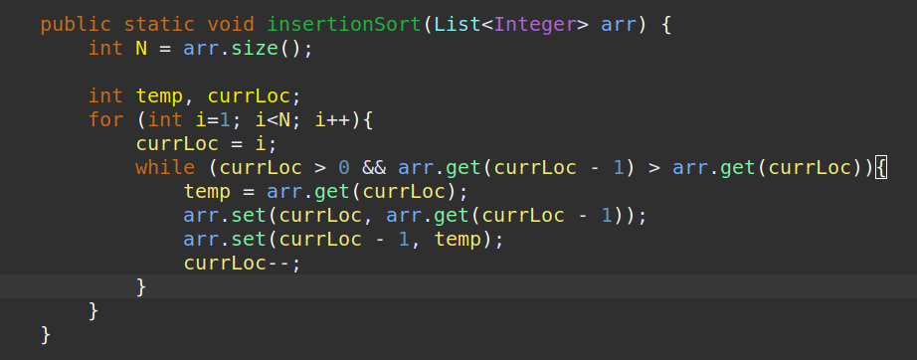

First the algorithms of insertion sort were implemented in Java code

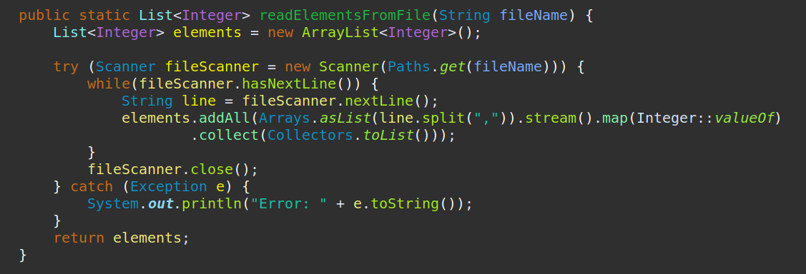

A function to read the datasets using a file name parameter was implemented.

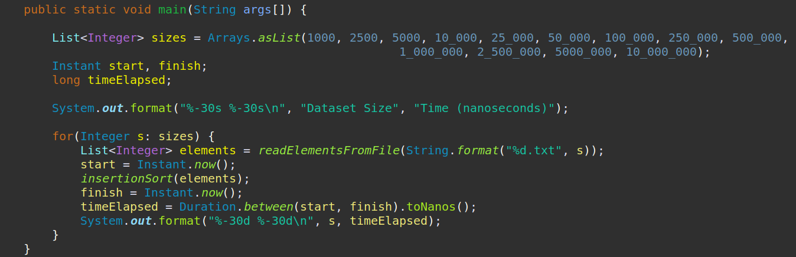

Function to calculate and print the time taken in nanoseconds by the insertion sort algorithm for each dataset was written. This produced our data for further study

Output

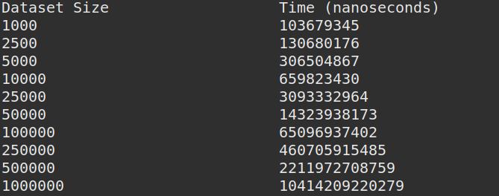

Dataset Size | Time (nanoseconds) | Time (seconds)
1000 | 103679345 | 0.103679345
2500 | 130680176 | 0.130680176
5000 | 306504867 | 0.306504867
10000 | 659823430 | 0.65982343
25000 | 3093332964 | 3.093332964
50000 | 14323938173 | 14.323938173
100000 | 65096937402 | 65.096937402
250000 | 460705915485 | 460.705915485
500000 | 2211972708759 | 2211.972708759
1000000 | 10414209220279 | 10414.209220279

Analysis and Conclusions

The running times for insertion sort:
- Worst case: Θ(n²).
- Best case: Θ(n).
- Average case for a random array: Θ(n²)
- "Almost sorted" case: Θ(n).
If you had to make a blanket statement that applies to all cases of insertion sort, you would have to say that it runs in O(n²) time. You cannot say that it runs in Θ(n²) time in all cases, since the best case runs in Θ(n) time. And you cannot say that it runs in Θ(n) time in all cases, since the worst-case running time is Θ(n²).

The Time Complexity of an algorithm/code is not equal to the actual time required to execute a particular code, but the number of times a statement executes.

The actual time required to execute code is machine-dependent and also it considers network load if your machine is in LAN/WAN.

Instead of measuring actual time required in executing each statement in the code,Time Complexity considers how many times each statement executes.

There is a clear evidence to support the theoretical model of time complexity, as we do eventually see significant increases of execution time with increasing input size. Thus the time complexity analysis is an excellent indicator for real world machine specific performance.

References
- https://www.educative.io/courses/visual-introduction-to-algorithms/kMABY
- https://brilliant.org/wiki/insertion/
- https://www.geeksforgeeks.org/insertion-sort/

